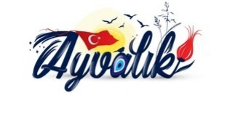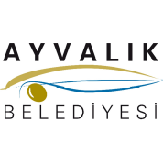
INTERNATIONAL FOLK DANCE ORGANIZATIONS
XI. International Sea & Sand Days Festival-Competition
25-29 JUNE 2027- AYVALIK

CONDITIONS OF PARTICIPATING :

Please, send this application form back by email with minimum 6 digital pictures and a short description of your group and videos or links and descriptions of your performances. Please send this emails to : ifdoturkey@gmail.com

2- The Groups will stay at hotel hotel (http://www.erginotel.com.tr, http://www.hotel-billurcu.com/tr/, https://www.mareayvalikhotel.com/, http://www.kalifhotel.com/ , https://cemgulhotel.com/ ) or similar hotels. Participants age are not limited.
3- The groups are requested to arrive in Ayvalık on 25 JUNE 2027 - 12:00 and depart on 29 JUNE 2027 - 12:00, after breakfast.
4- Gifts provide for each person is an attendance certificate. Each group should bring flags of their countries with them.
5- We will prefer for dance groups with live music but recorded music also acceptable.
6- Pocket money will not be paid to the groups by Festival Committee.
7- The groups will prepare 5-10 minutes programs. All groups have to prepare minimum 2 different performances.
Participating groups will be rewarded for the best music, best costume, best performance and choreography

8- The competition fee is 230 euro per person (Mare otel. Kalif Otel, Cemgül Otel )
The competition fee is 240 euro per person (Ergin hotel,Billurcu hotel )

It covers organizational expenses, accommodation in a Hotel for 4 nights with 2 meals per day. ( Open buffet breakfast, and dinner. ) As the festival committee, we can only provide 4 double rooms. Other accommodation options will be in triple and quadruple rooms. On every 25 participants one member is free of charge. For double rooms there is a supplement of 10 € per person per day, for single room 25 € per person per day. It is your responsibility to have International health insurance when coming to our festival
PAYMENT: As confirmation of its participation in the festival, a group pays in advance 2000 € (which is not reimbursable in case of declination of participation). The rest of the amount is to be paid 15 days before the festival or at the group’s arrival to the hotel, according to the agreement Last application and deposit 15.3.2027
11- Contact persons of Festival Committee ;

Salih ÖNSOY kararitim61@hotmail.com gsm : 0090 542 216 39 46
Murat ERDEM merdem_65@hotmail.com gsm : 0090 545 494 83 75

