IN 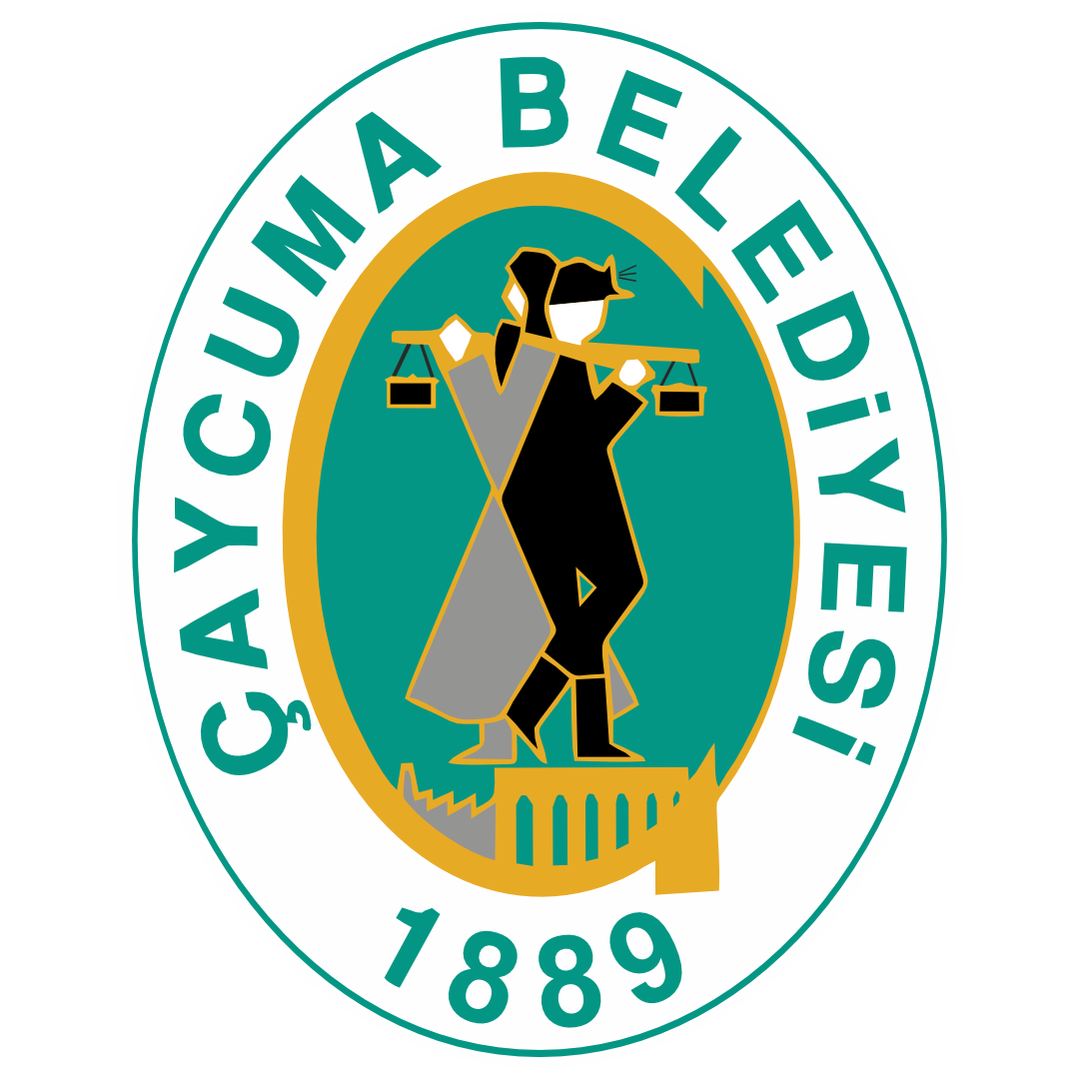 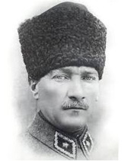 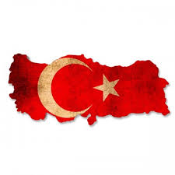 

GANIZATIONS 4-04
ÇAYCUMA
II.International Culture, Art and Tourism Festival.
15-19 June 2027

CONDITIONS OF PARTICIPATING :

1- Please, send this application form back by email with minimum 6 digital pictures and a short description of your group and videos or links and descriptions of your performances. Please send this emails to : ifdoturkey@gmail.com merdem_65@hotmail.com or kararitim61@hotmail.com

2- The Groups will stay at hostel. 2 and 3 beds in a room . The number of participants must be 40 people with driver. Participiant fee 50 euro

3- The groups are requested to arrive in Çaycuma on 15 June 2027 - 12:00 and depart on 19 June 2027 - 10:00, after breakfast.

4- Gifts provide for each person is an attendance festival hat-t-shirt and certificate.

5- Each group should bring flags of their countries with them. For gift exchange, each country must bring 4 gifts.

6. We will prefer for dance groups with live music but recorded music also acceptable.

7- Pocket money will not be paid to the groups by Festival Committee. We will give 200 lt diesel.

8- The groups will prepare 5-10 minutes programs. All groups have to prepare minimum 2 different performances.

9.Contact persons of Festival Committee ;

Salih ÖNSOY kararitim61@hotmail.com gsm : 0090 542 216 39 46
Murat ERDEM merdem_65@hotmail.com gsm : 0090 545 494 83 75

